**1. Introduction**

A Location Based Services (LBS) is a software application for a mobile device that requires knowledge about where the mobile device is located. Location Based Services provides the information about the location of users based on the mobile phone through mobile service Network, and also find the location of the mobile phone. Location Based Services (LBS) are used in different organizations like Social networks, health services, banking, airplane services, and indoor and outdoor object search. LBS are frequently used by mobile users for tracking locations.

The Location Based Services can be further classified into two categories. These are indoor localization and outdoor localization. Global Positioning System (GPS) is used for outdoor localization and its used for satellite navigation system and tracking locations. GPS is designed based on radio navigation system. The Global Positioning System worked with LBS is used for tracking the location of mobile phones. The primary role of GPS is to calculate the coordinates, like longitude and latitude, based on GPS receiver. By using a GPS system in our mobile phones, we can find the navigation route from a current source to the required destination. The GPS system contains 24 satellites, but three satellites may be enough for tracking the location of mobile phones. A GPS signal works only in open areas and doesn’t reach the closed areas like interior of the apartment.

**2. Wireless Technologies for Indoor Localization**

Indoor localization provides the services in large shopping malls and closed area networks. The indoor localization provides the navigation to particular places in the mall like the Movie Theater, the gaming center, and the public rooms. Indoor localization is used for robot navigation system, and also help full for blind people to walk in indoor locations. Indoor localization contains particular problems like high none line of sight (NLOS), movement of human beings, smaller dimensions, and other factors [2].

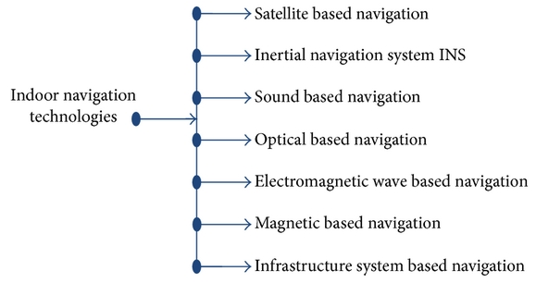 Fig.1: Indoor Navigation Technologies [2].

Wireless technologies used in indoor localization are divided into three technologies. Namely long distance technologies, middle distance technologies, and short distance technologies .These technologies are used based on the frequency usage.

Frequency Modulation is one of the long distance technologies, which is used throughout the world for broadcasting the local radios. Most places use frequency range between 87.5 to 108.0 MHZ [2]. In Frequency Modulation, usage of very high frequency is approximately less compared to wireless technologies like Wi-Fi. Frequency Modulation ranges around 100 Km surrounding, and it doesn't require a particular infrastructure which takes very less power consumption. The cost of Frequency Modulation is very low and also consumes less battery power. The major drawback of Frequency Modulation is that signals change in very short distances.

GSM/CDMA is another longest distance technology, which is used in cellular network connection. The range of frequencies varies from one region to another region and range in frequencies between, 850 MHZ to 1900 MHZ. The mobile network is covered with particular locations, so it doesn't require the extra infrastructure. The cost of the GSM/CDMA technology is very low compare to other wireless technologies and contains high patented.

Wireless Fidelity (Wi-Fi) is the one of the middle distance wireless technologies. Wi-Fi, defined as wireless local Area network (WLAN), is based on IEEE 802.11 standards. The frequency ranges between 2.5 MHZ to 5 MHZ bands. The Wi-Fi network can be accessed in shopping malls, airports, universities, and public places through the Wi-Fi hotspot provider. The cost infrastructure is very low in Wi-Fi because it supports the many electronic devices like mobile phones, PDA’s, and laptops etc. Wi-Fi connection takes high power consumption, and signals can be varies highly. Wi-Fi technology is the main stream technology in indoor localization [2].

There are many short distance wireless technologies.Bluetooth is the one of the wireless technology which is used to transfer the information from one device to another device in particular surrounding places. The frequency range in networks is between 2.4 GHZ and 2.485 GHZ. The Bluetooth technology is widely used to share the data in laptops, mobile phones, and tablets. It involves very low power consumption compared to other wireless technologies but covers limited range network.

Radio frequency identification is one of the short distance technologies. RFID contain two parts: Tag and reader, which is used to transfer the data through electromagnetic field for identifying the objects with attached tags. This technology is used in many applications like Data Warehouse management, combine the automobile industry, and chain network. The frequency range of RFID is very low, it contains the very dedicated infrastructure, and it takes very low power consumption. RFID empowers a restricted remote correspondence utilizing a noncontact and propelled programmed recognizable proof innovation that uses radio flags that put a RFID tag on individuals or items, with the main purpose of automatic identification.

**3. Wireless Technologies for Outdoor Localization**

Global Positioning System (GPS) is the one of the procedures in outdoor localization. The GPS is the radio navigation system utilized for discovering the location of the object throughout the world .GPS is a good technology for outdoor localization, which is used for only outdoor environments. GPS was introduced by United States Department of Defense. GPS doesn't work well in indoor setups, because of hindrances in the viewable pathway between the satellite and the receiver. Electromagnetic waves is spread and weakened by the structures and outside obstructions. The power consumption and cost of GPS is very high .GPS receiver calculates the time based on the transmission of starting time, and it triangulates the current position by using distance between multiple satellites.

**4. Wireless Indoor Tracking System (WITS)**

Mobile Technology has changed very highly from day to day life. Mobile phone performance has updated every time because of high memory storage and increase CPU speed. Technology change in mobile phones is include high screen resolution camera, large storage space, Bluetooth, and Wi-Fi technology. Now-a-day's Wi-Fi is an important feature in the mobile device. Using Wi-Fi we can access the internet in universities, houses, bus stations, and shopping malls.

Wireless indoor tracking system is used to track the location of mobile phones in a particular place .This system contains a server, client, builder, and RSS radio map. It can be implemented based on the existing Wireless Local Area Network (WLAN).WITS server is like a computer, which is works on location determination algorithms [3].

WITS server receives the request from the client and tracks the location using tracking and positioning algorithms. WITS server also sends back the location information to the client. The WITS client is pre-installed in mobile phones. The current received signal strength, sends tracking request with the received signal strength to WITS server, and shows the estimated location on the map after receiving reply a from it [3].

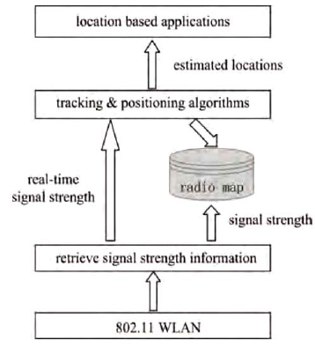 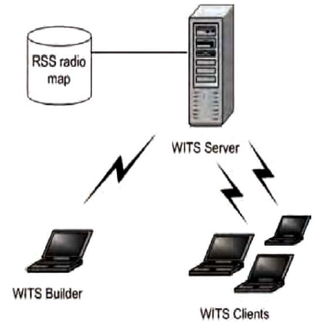

Fig.2: Working steps of WITS [3]. Fig.3: WITS Client-Server Architecture [3].

WITS clients are also required to register in the server, because it uses the position of a particular person before tracing the mobile clients. WITS builder receives the request signals from various clients and sends the request signal to WITS server, these are stored in a RSS database making the RSS radio map.RSS database is used for implementation of Microsoft Access [3].

**5.Conclusion**

In this paper, different types of indoor and outdoor wireless technologies are explained. Wi-Fi is the one of the most important wireless technology, because we can access the internet any place like shopping malls, educational institutes, airports, and some closed areas. By using Wi-Fi technology we can track the location of a mobile device. Moreover, categories of Location Based Services (LBS) has mentioned for location tracking. GPS is one of the best service providers in outdoor localization, but it doesn't work well indoor places.

References:

[1] Dhole, P., Hirve, S., Tekawade, A., Tutake, A., Shinde, A., Mobile Tracking Application for Locating Friends using LBS, *IJIRCCE,* 1, 2 (Apr. 2013), 2320-9798.

[2] Farid, Z., Ismail, M., Nordin, R., Recent Advances in Wireless Indoor Localization Techniques and System, *Journal of Computer Networks and Communications*, 2013, 185138, (Aug.2013), 12.

[3] Gosai, A., Raval, R., Real Time Location based Tracking using WIFI Signals*, International Journal of Computer Applications,* 101, (Sep,2014), (0975 – 8887).